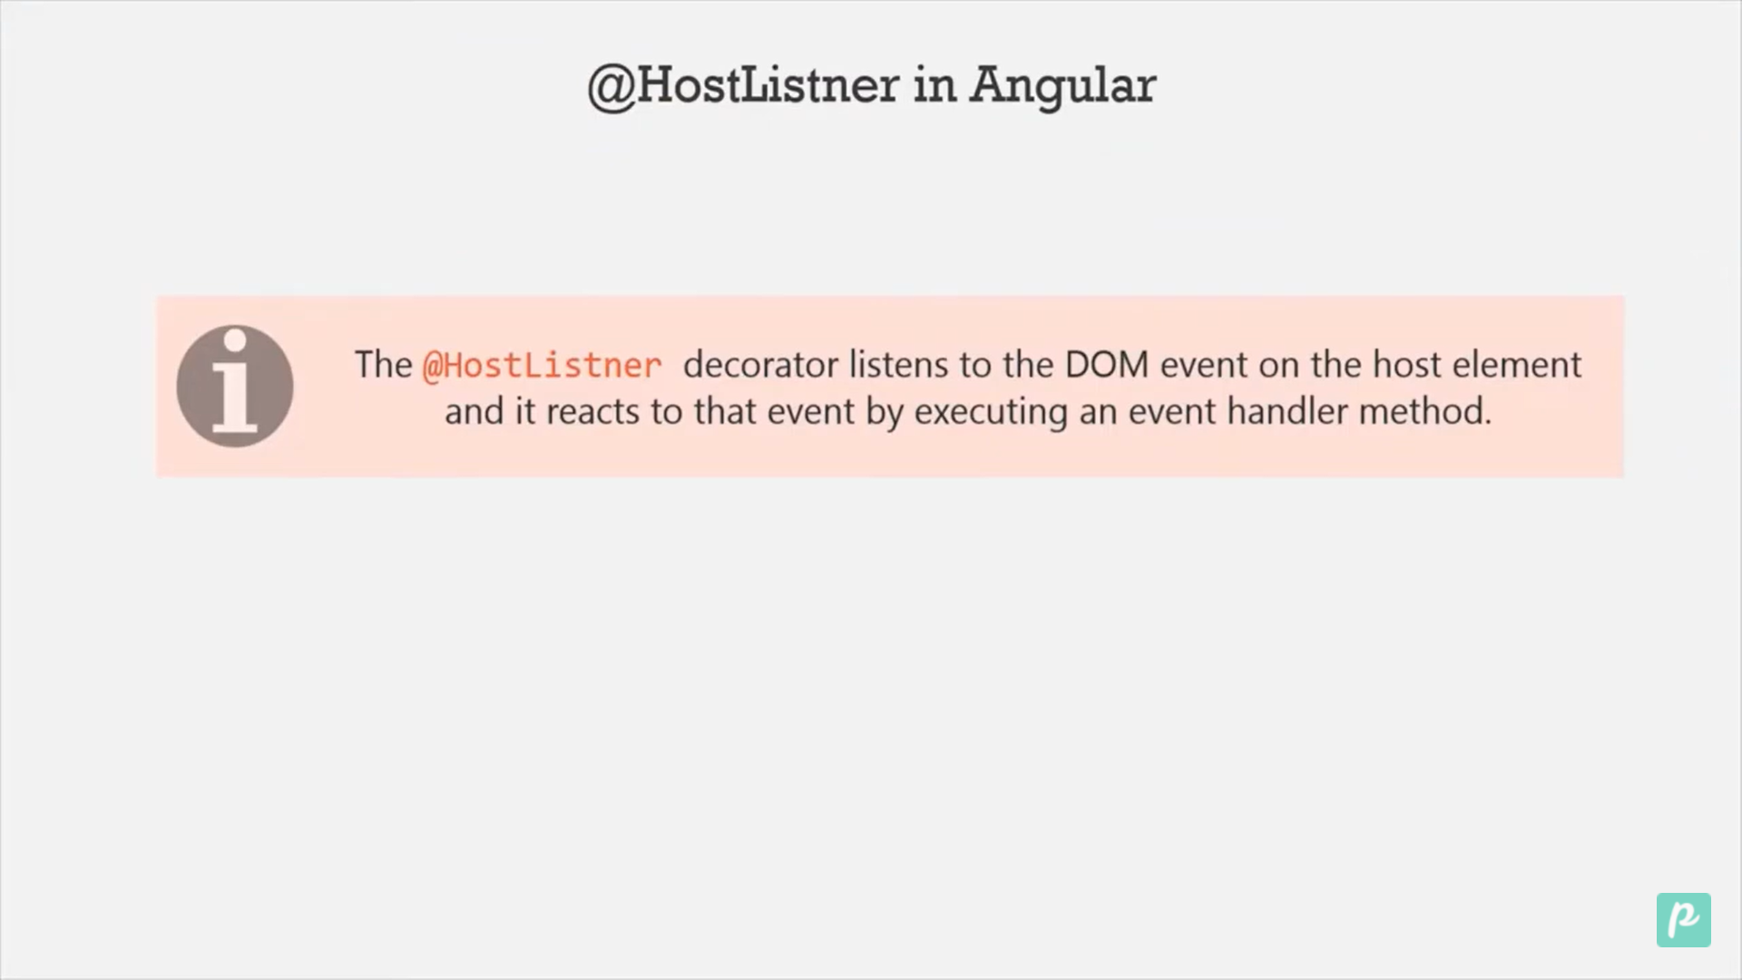@Directive({

  selector: '[appHostlistner]',

})

export class HostlistnerDirective {

  constructor(private element: ElementRef, private render: Renderer2) {}

  @HostListener('mouseenter') onmouse() {

    this.render.setStyle(this.element.nativeElement, 'margin', '5px 10px');

  }

}

Here we are creating method that will listen to dom event.

<!-- HostListnet -->

<div class="container" appHostlistner>

  <div class="row">

    <div class="col-6 offset-4">

      <span style="height: 120px; width: 120px">We will HostListnet</span>

      <span style="height: 120px; width: 120px">We will HostListnet</span>

    </div>

  </div>

</div>